Golden Bear Dinner – Friday, September 26
Class of 1970 and 1975 to be inducted.

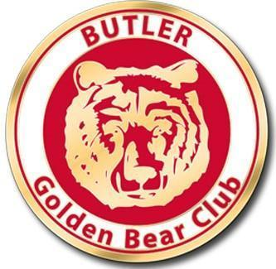
The Suda E. Butler High School Alumni Association (SEBAA) invites you and your guest(s) to celebrate the induction of the Class of 1970 and 1975 into the Butler Golden Bear Club. This club is organized for folks who have been associated with Butler High School for 50 or more years. At this meeting, former students, teachers and staff associated with the class of 1970, 1975, and 1965 will be inducted into the club, as well as those from earlier classes not previously inducted.

This year’s induction and celebration will be held on Friday, September 26, 2025, at Butler High School’s Alumni Hall. Registration and social hour begin at 5 p.m. Dinner will be served at 6 p.m., with the induction following.

The dinner will be catered and those being inducted into the Golden Bear Club will be presented with a unique lapel pin commemorating this occasion. The total cost for this event is $40 per person.

You can register by clicking this link below
Everyone must use this link below to register for the Golden Bear Event on September 26
Online Registration Form

Payments by check can be mailed to SEBAA, PO Box 16685, Louisville, KY 40256-0685.
MAKE ALL CHECKS PAYABLE TO SEBAA. Include your name and grad year on the check

Or pay by Venmo to @SEBAA25
If you pay by check or Venmo please include your name and what graduating class you were in.

Questions can be emailed to the Alumni Association at admin@butlerhighalumni.com

RESERVATIONS ARE DUE NO LATER THAN WEDNESDAY SEPTEMBER 15, 2025.
We’ll also have a slideshow during the Golden Bear Dinner. If you have any photos you’d like to include in this show, please email them to SEBAA Executive Director Brittany Braun no later than 9/17/25 (admin@butlerhighalumni.com)
We will also have a photo booth that night for you to get selfies while you are at the event to take home.
If you have not already joined SEBAA, lifetime memberships will be available at the dinner for a one-time donation of $25.

